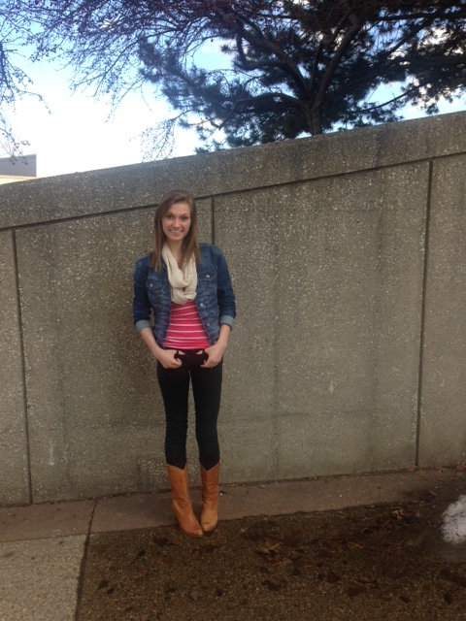

***What do I have to offer?***

I will promote a loving, active learning environment. With strengths in the areas of encouragement, communication, and developing others, a dynamic learning experience is ensured.

***Education:***

Jenison High School

Cornerstone University

***My Philosophy:***

My role is to inspire, nurture, and equip each student for the path to success. Learning in my classroom will be interactive, engaging, and meaningful. Not only will I teach the material, but I will care about each and every student along the way.

**Meet Miss Bell**

***What do I like to do?***

I love to be outdoors, spend time with my family, and take lots of pictures. Every day is an adventure, and I’m always excited about it!

***Why Kindergarten?***

I have such a passion for helping young learners grow and achieve. The early years of school are some of the most important, and I want to walk alongside each student as they explore their classroom experience.

**Contact:**

*Phone:*

(616) 581-3680

*E-mail:*

Jacqueline.Bell@corerstone.edu

***My Mission Statement*:**

I will encourage, motivate, and guide students to be *active learners* in their everyday lives. I will appreciate each unique quality of my students, and accommodate all to the best of my ability. I will teach each student to be *kind, gracious, and courageous* in every moment, as well as modeling those qualities in my own life. I believe that every single student is made in the image of God, and has immense potential and ability; and I will do everything I can to help them live it out. When my students leave the classroom, I want them to feel cared for and excited to learn.